Hannover Messe 2025
The future of industry is AI-driven:
Eplan & Rittal to highlight AI-driven industrial automation at Hannover Messe
Herborn/Monheim, 6 March 2025.
Growing the business in the face of international competition is a constant challenge for industrial companies, above all in Europe and most particularly in Germany. As a result of artificial intelligence, a whole host of opportunities are also at the same time presented, especially in mechanical, electrical, process and plant engineering. At Hannover Messe 2025, Eplan and Rittal will demonstrate how AI can help companies drive forward and be ready for the future with several practical and real-life project case studies, involving Siemens and Microsoft. The theme: AI-driven industrial automation is the future. What’s more, visitors will be able to see other high-tech innovations, including Rittal’s Direct Liquid Chip Cooling, which makes AI applications in data centres technologically possible in the first place. There are also innovations and developments in Eplan software, Rittal power distribution and enclosure technology, as well as copper processing and machining with Rittal Automation Systems.
“AI leadership and software expertise combined with deep industry knowledge are the key levers for a new growth curve and international competitiveness for industrial companies,” says Professor Niko Mohr, member of the Executive Board of the Friedhelm Loh Group and CEO of Rittal International and Rittal Software Systems. He adds: “The future will be driven by AI, especially in plant planning, design and engineering. Eplan and Rittal are pioneering and advancing industrial automation forward through AI and showing how this technology will improve mechanical, electrical, process and plant engineering tomorrow.”
At Hannover Messe, these two Friedhelm Loh Group companies will provide answers how AI will soon be helping electrical designers, engineers and planners improve their daily work in new and innovative ways. Eplan and Rittal have already put together real-life project case studies, like the AI-assisted generation of mounting plate layouts based on Microsoft Azure Open AI Service. Eplan is working with Siemens on extensive end-to-end integration that will digitise and automate the entire engineering process in the future. “If AI systems can interconnect with each other, both across the board and independently, we will raise the benefits for customers to a whole new level. In automation technology, for example, there are considerable efficiency gains to be had, such as a reduction in costly design and planning time. AI-assisted tools allow developers to simulate a variety of different scenarios in just a few minutes, something that would previously have taken days or even weeks. This not only saves time but also significantly and consistently improves the quality of the outcomes,” says Sebastian Seitz, CEO of Eplan. The ambition and objective is quite clear: To utilise AI in current solutions to meet industry’s specific requirements and to automate the entire engineering process.
AI needs data – of the highest quality and in standardised formats
The basis for any automation solution, even if using AI, is first-class data. This challenge is met by the requirement that Eplan established years ago with the EDS data standard, i.e. fully detailed, documented and standardised article data. Now, the Eplan Data Portal contains over four million data records for users. Moreover, in Hanover, Eplan will present the upcoming Eplan Platform 2026. As a preview, visitors will gain the first insights into functional expansions to the engineering solutions.

Is current IT infrastructure AI-ready?
The Hannover Messe is showcasing a wide range of AI applications that promise revolutionary economic benefits. But are data centres ready? Computing power and power density for AI represent new technological territory, as the physical limits of established and existing air cooling are exceeded. Rittal is showcasing a completely new type of Coolant Distribution Unit (CDU) that uses direct water-based chip cooling to deliver over 1 megawatt of cooling output, thereby enabling data centres to be used for AI applications in the first place.

Consistent standardisation accelerates power distribution
Digital transformation and energy transition require electrical power – and lots of it! The new RiLineX system platform speeds up the production of power distribution in control and switchgear construction, so that time savings of up to 75% can be achieved during assembly. At the trade fair, Rittal will present eight new distribution boards in the standard enclosure widths for 550 A and 800 A or 380 kW and 500 kW. With a systemised platform approach, the company is driving forward international standardisation. It has launched a network of technology partners who are developing ‘Ready for RiLineX’ components that can be directly connected through a click system to the distribution board. At the trade fair, Rittal will introduce new partners who cover a wide, future-proof range of applications for AC and DC current.

New products also on show include copper processing machines from Rittal Automation Systems, like the Bending Terminal BT 20E, as well as new system enclosure solutions. For example, the new AX IT Nano DC safeguards and protects ever-growing IT infrastructure, such as servers and switches, in harsh industrial environments. AX compact enclosures are now also available in new sizes that are particularly suitable for use with underfloor enclosures or for logistics conveyor applications.

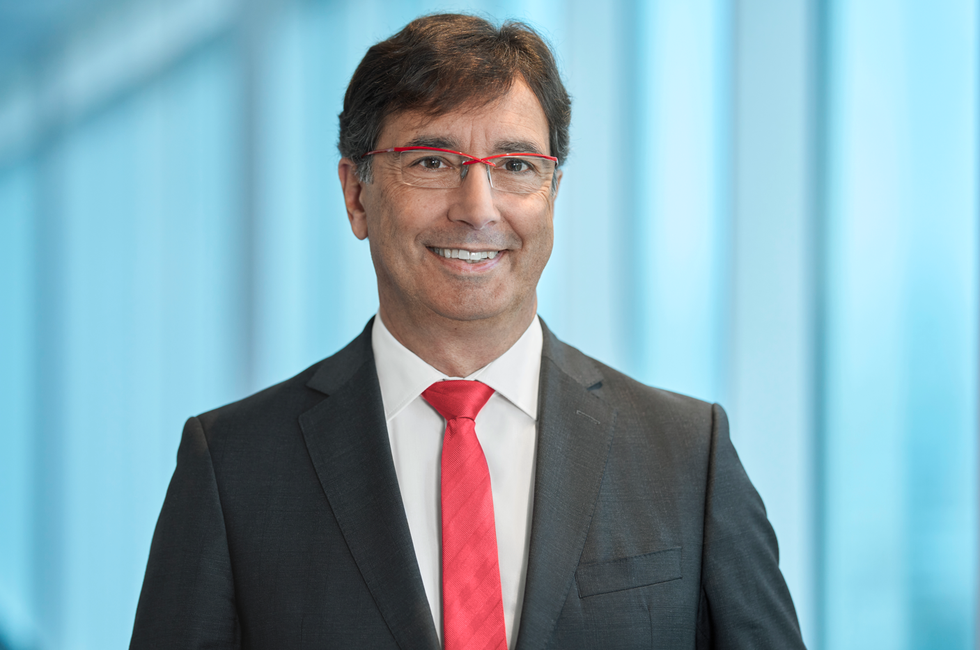
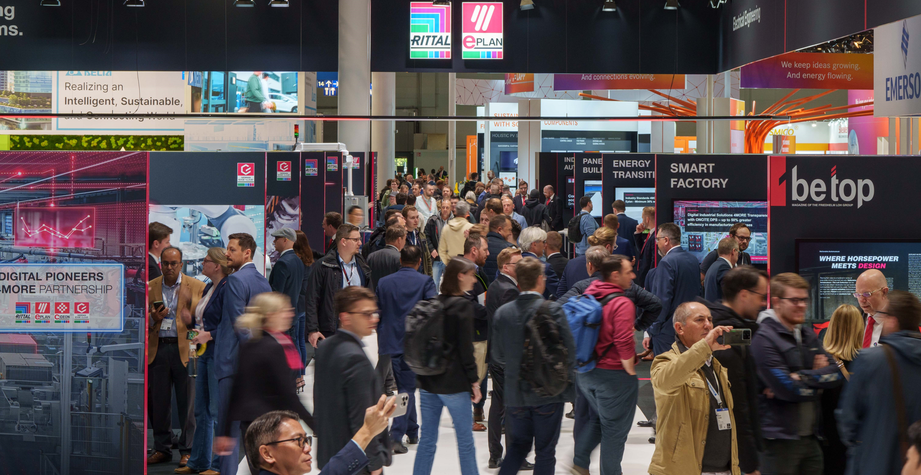

Caption, image 1  Eplan and Rittal provide answers how AI will soon be helping electrical designers, engineers and planners improve their daily work in new and innovative ways. |  | Caption, image 2  Professor Niko Mohr: “AI leadership and software expertise combined with deep industry knowledge are the key levers for a new growth curve and international competitiveness for industrial companies.”


Caption, image 3
Sebastian Seitz: “If AI systems can interconnect with each other, both across the board and independently, we will raise the benefits for customers to a whole new level.”

May be reproduced free of charge. Please name Rittal GmbH & Co. KG / Eplan GmbH & Co. KG as the source.

Rittal

Rittal is a leading global supplier of enclosure systems, automation and infrastructure with its industrial, IT, energy and power, cooling and service units. Rittal products and solutions are used in over 90% of global industries – standardised, customised, and always of the very best quality.
Our approach and methodology: Rittal, Rittal Software Systems (Eplan, Cideon) and Rittal Automation Systems (RAS, Ehrt, Alfra) combine their hardware and software expertise to streamline, optimise and digitalise processes across the entire value chain for our customers including their IT infrastructure – from control and switchgear construction, machine building to factory operators or the energy sector.
Our delivery promise: Rittal standard products are delivered in Germany within 24 hours, and within 48 hours throughout Europe.
Customer focus
Improving efficiency and increasing productivity through automation and digitalisation is one of the biggest challenges for our customers. This requires in-depth knowledge and expertise, the combination of hardware and software, and cross-sector networking. We are convinced that creating and connecting data rooms is crucial to the success of industrial transformation. And that is exactly our speciality and field of competence.
Eplan and Rittal are driving the development of the digital automation twin, making data accessible and useable in operations as well. Cideon is improving data consistency in the digital product twin context with its CAD/CAM, PDM/PLM and product configuration expertise.
Sustainability
Environmental and climate protection, social commitment and ethical corporate management are a given for Rittal. We take our responsibility for a sustainable future seriously. Our approach to resource management and conservation involves continuous improvement of our own production processes and ensuring that our products have the lowest possible Product Carbon Footprint. Our solutions support our customers in achieving their own climate targets.
Family business and global player
Founded in 1961, Rittal is the largest company in the owner-operated Friedhelm Loh Group. The group operates worldwide, with 12 production sites and 95 international subsidiaries. It has 12,100 employees and posted revenues of 3 billion euros in fiscal 2023. In 2023, the Friedhelm Loh Group was presented with the “Best Place to Learn” and “Employer of the Future” awards. In 2024, Rittal was awarded the Top 100 Seal as one of Germany’s most innovative medium-sized companies for the third time in a row.
Further information can be found at www.rittal.de and www.friedhelm-loh-group.de.

Corporate Communications
Dr. Carola Hilbrand Rittal GmbH & Co. KG
Corporate & Brand Communications Auf dem Stützelberg
Phone: +49 (0)2772/505-2527 35745 Herborn, Germany
hilbrand.c@rittal.de www.rittal.com

Eplan

Eplan provides design, planning and engineering software and service solutions for all aspects of electrical, automation and mechatronic engineering. The company has developed one of the world’s leading design software solutions for machine and panel builders. Eplan is also the ideal partner to simplify and streamline complex and challenging engineering processes.

Both standardised, as well as customer-specific interfaces to ERP and PLM/PDM systems, ensure data consistency across the entire value chain. Working with Eplan means seamless communication across all engineering disciplines. Regardless of whether the company is large or small: It allows customers to use their expertise more efficiently. Worldwide, EPLAN serves and supports over 68,000 customers. Together with its customers and partners, EPLAN strives to continue growing and actively advancing integration and automation in engineering. Within the Eplan Partner Network, open interfaces and seamless integrations are implemented together with partners. “Efficient engineering” is Eplan’s core focus.

Eplan was founded in 1984 and is part of the owner-operated Friedhelm Loh Group. The group operates worldwide, with more than 12 production sites and 95 international subsidiaries. It has 12,100 employees and posted revenues of 3 billion euros in fiscal 2023. In 2023, the Friedhelm Loh Group was presented with the “Best Place to Learn” and “Employer of the Future” awards.
For more information, visit www.eplan.com and www.friedhelm-loh-group.com.

Corporate Communications
Birgit Hagelschuer Eplan GmbH & Co. KG
Press and Public Relations An der alten Ziegelei 2
Tel.: +49 2173 3964-180 40789 Monheim am Rhein
Hagelschuer.b@eplan.de www.eplan.com

